King Fahd University of Petroleum and Minerals
Information and Computer Science Department

ICS 103: Computer Programming in C
Spring Semester 2006-2007 (Term-062)

Major Exam-I

Time:100 minutes Wednesday, March 28, 2007

Name:
ID#:

PLEASE CIRCLE YOUR SECTION BELOW:

Section | 01 | 02 | 03 | 04 | 05 | 06 | 7
Time | SM-8-9 | SM 9-10 | SM 11-12 | UT 9-10 | UT 11:12 | UT 8-9 | UT 10-11

Note:

- Copying or Discussion will result in zero grade for all the students involved.
- Attempt all questions.

Question # | Maximum Marks | Obtained Marks
1 | 7 x 2 = 14
2 | 10
3 | 10
4 | 10
5 | 6
6 | 6
7 | 8
8 | 8
9 | 14
10 | 14
Total | 100

Question 1: (14 points)

Find the values of the following expressions

expression | Value
-3<=-2<=-1 | 0
5>3>=2+1 | 0
3&&2*!0||!1 | 1
!5<7+1&&5-2>3 | 0
6+3<5&&!5-3>6 | 0
-3+3*-5%4+(5-2)/2.0 | -4.5
11.5-(2+3*(7-4)/4) | 7.5

Question 2 (10 points )

Write the corresponding mathematical or C expression

C EXPRESSION | Mathematical Expression
(pow(x,sqrt(y))-z*z)/(x+y) | $$\frac{x^{\sqrt{y}}−z^{2}}{x+y}$$
pow(sqrt(x)+y,0.5) | $$\sqrt{\sqrt{x}+y}$$
1.0/3*x*y-7.0/(pow(x,y)+2) | $$\frac{1}{3}\text{xy}−\frac{7}{x^{y}+2}$$
1+exp(y+x)/y-sqrt(z) | $1+\frac{e^{y+x}}{y}−\sqrt{z}$

Question 3: 10 points
Show the output of the following program in the space provided below it. Each square corresponds to one space

#include <stdio.h>
int main(void) {
int x=-635;
double y=34.678;
printf("%8.2lf%3d\n",y,x);
printf("%11.4lf%6d%4.3lf\n",y,x,y);
return 0;
}

1 | 2 | 3 | 4 | 5 | 6 | 7 | 8 | 9 | 0 | 1 | 2 | 3 | 4 | 5 | 6 | 7 | 8 | 9 | 0 | 1 | 2 | 3
 |  |  | 3 | 4 | . | 6 | 8 | - | 6 | 3 | 5
 |  |  |  | 3 | 4 | . | 6 | 7 | 8 | 0 |  |  | - | 6 | 3 | 5 | 3 | 4 | . | 6 | 7 | 8

Question 4: 10 points
Consider the following program

int main() {
double x;
printf("enter a value for x >");
scanf("%lf",&x);
if(x<85)
printf("5");
else if (x<75)
printf("1");
else if(x<90)
printf("2");
else if( x>85)
printf("4");
else
printf("3");
return 0;
}

The above program compiles and runs without errors. Indicate the range of the values of x (entered by the user) for each of the values printed by the program. You have to choose the exact range.

- It cannot be printed
- x ≥ 75
Value printed  By the program | Range of x values typed by the user (Choose from a,b,c,d, e,f, g,h)
1 | a
2 | e
3 | a
4 | h
5 | g
- x < 75
- 75 ≤x < 85
- 85 ≤ x < 90
- 75 ≤x < 90
- x < 85
- x ≥ 90

Question 5 (6 points)
What is the output of the following program

#include <stdio.h>
int main() {
int x=0,i;
x=5
x=9
i=6
for (i=0;i<=4;i=i+3) {
switch(i-2) {
case 0:
case -1: x=x+2; break;
case 2:
case 1: x=x+1;
case 4:
case 3: x=x+3; break;
default : x+=5;
}
printf("x=%d\n",x);
}
printf("i=%d\n",i);
return 0;
}

Question 6 (6 points)

What is the output of the following program.

#include <stdio.h>
int main() {
int i,j;
i=5;
8 9
7 8
3 5
do {
j=3;
do {
printf("%d ",i+j);
j++;
} while(j<5);
printf("\n");
i--;
} while(i>3);
printf("%d %d",i,j);
return 0;
}

Question 7 (8 points)
Rewrite the shaded part of the following program fragment by converting the for loops into equivalent while loops.

double sum = 0 ;
int i, j;
for (i = 5; i < 40; i = i + 5) {
for (j = -i; j <= 0; j = j + i / 3)
sum = sum + i * j;
printf("sum =%lf\n",sum);
}

i = 5;

while(i < 40)
{

j = -i;

while(j <= 0)
{

sum = sum + i * j;

j = j + i / 3;
}

printf("sum =%lf\n",sum);

i = i + 5;
}

Question 8 (8 points)
Rewrite the following c program using switch instead of if-else if

if(i==1||i==-5)
x=x+2;
else if(i==8)
x=x+3;
else if (i==10||i==11||i==12)
x=x+5;
else
x=x+7;
switch (i) {
case 1 :

case -5: x=x+2;
break;

case 8: x=x+3;
break;

case 10:
case 11:
case 12: x=x+5;
break;

default: x=x+7;

}
Question 9 (14 points)
Write a program that asks the user to enter 10 integer numbers, one number each time. Using a loop, you program will read the entered numbers and count how many odd numbers the user has entered. After the loop, your program will display how many odd numbers entered.
The following is a sample execution of your program.

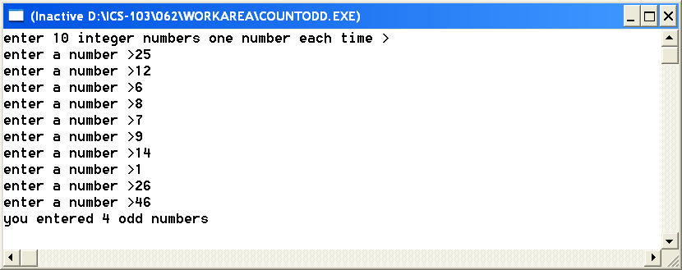
#include <stdio.h>
int main() {

int number,i,count=0;

printf("enter 10 integer numbers one number each time >\n");

for(i=0;i<10;i++) {
printf("enter a number >");

scanf("%d",&number);

if(number%2==1) // or n%2!=0

count++;
}

printf("you entered %d odd numbers",count);

return 0;
}

Question 10 (14 points)
Write a program that asks the user to enter 3 real numbers. Your program will find the maximum and display it.
The following is a sample execution of your program.
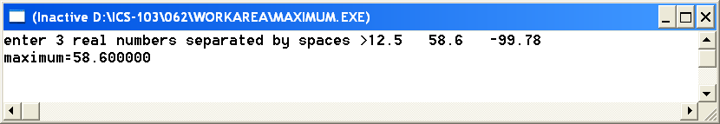

#include <stdio.h>
int main() {

double max,n1,n2,n3;

printf("enter 3 real numbers separated by spaces >");
scanf("%lf%lf%lf",&n1,&n2,&n3);

if(n1>n2&&n1>n3)

max=n1;

else if (n2 > n3 )

max =n2;

else

max= n3;

printf("maximum=%lf",max);

return 0;
}

